零件信息：
车顶多功能拓展平台安装说明书

车 型： 坦克300 满顶 （半顶支架减少，横梁减少）

工 时 ： 40 Min
安装前请仔细阅读本安装说明书，以确保正确安装；
为确保可靠性，请严格安装步骤进行安装。

零件构成

请务必在作业前对构成零件进行确认：
序号 | 图片 | 产品名称 | 单车用量  (q | 备注
1 | 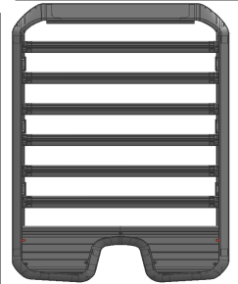 | 车顶平台  (Roof Rack) | 1
2 | 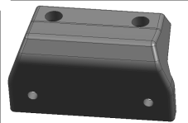 | 安装支架  (Bracket) | 6
3 |  | 110x30x4.5定制螺丝架  (Screw rack) | 6
4 |  | 80x18x4.5  双孔垫片  (Double hole spacer） | 6
5 | 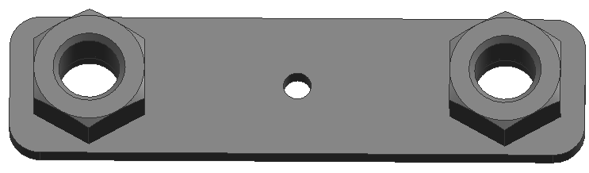 | 83x21x3 螺帽垫片  (Nut spacer) | 6
6 | 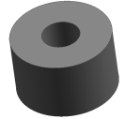 | 16x10x6圆柱  (Cylinder) | 7
8 |  | 8x40圆柱螺丝  (Cylindrical screw) | 12
9 |  | 8x20垫片  (Spacer) | 12
10 | 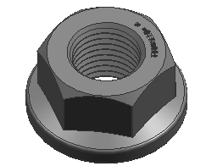 | M8法兰螺帽  (Flange nut) | 12
11 | 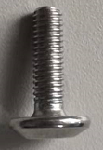 | 6x20大盘头螺丝  (Large pan head screw) | 20 | 不锈钢
12 | 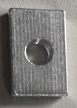 | M6-13x20x5方螺母  (Square nut) | 15
13 | 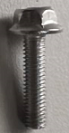 | 5x20外六角螺丝  (Hexagon Screw) | 10 | 不锈钢
14 | 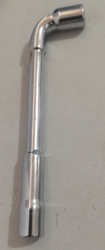 | 12mm套筒扳手  (Socket wrench) | 1
15 |  | 8mm套筒扳手  (Socket wrench) | 1
16 |  | 5mm  内六角扳手  (Allen wrench) | 1
17 |  | 6mm  内六角扳手  (Allen wrench) | 1
18
安装步骤：

1 | 安装准备：  ◄ 取出零件确保零件本身完整且整洁。  Remove the parts and make sure they are complete and clean.  ◄ 将组装安好的车顶平台平放在有保护的地面上防止磕伤、划伤。  Place the assembled roof platform flat on a protected ground to prevent bumps and scratches  （如需要安装攀梯先安装攀梯）  Install the ladder firstly if you buy it.  取下原车行李架后塑料盖板，划入110x30x4.5定制螺丝架 *6个。原车行李框后塑料盖板复原。  Remove the rear plastic cover of the original roof rack and insert 6 screw racks of 110x30x4.5. Restorae original rear plastic cover of roof rack.  注意后1定制螺丝架与 原车行李框后塑料盖板之间留6公分距离。如图。(左右相同)  Note: There is a 6 cm distance between the rear screw bracket and the rear plastic cover of the original car roof rack. As shown in the picture. (Same as left and right) | 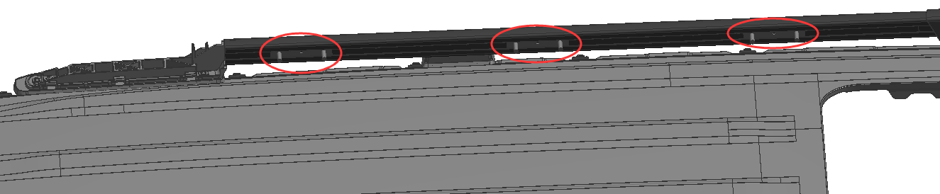  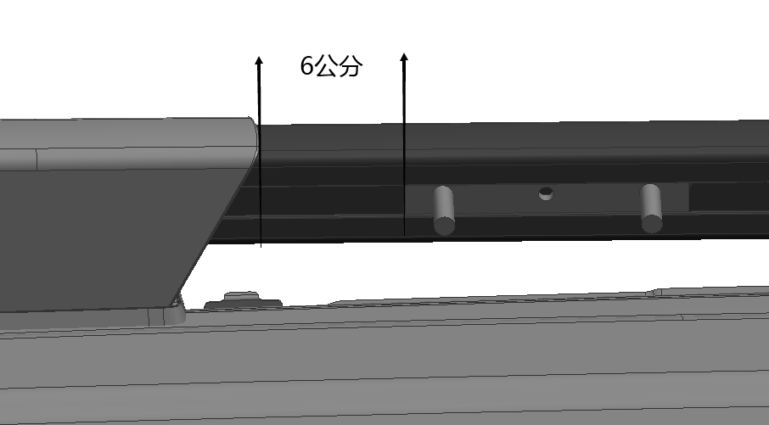  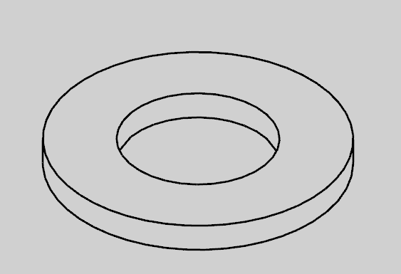  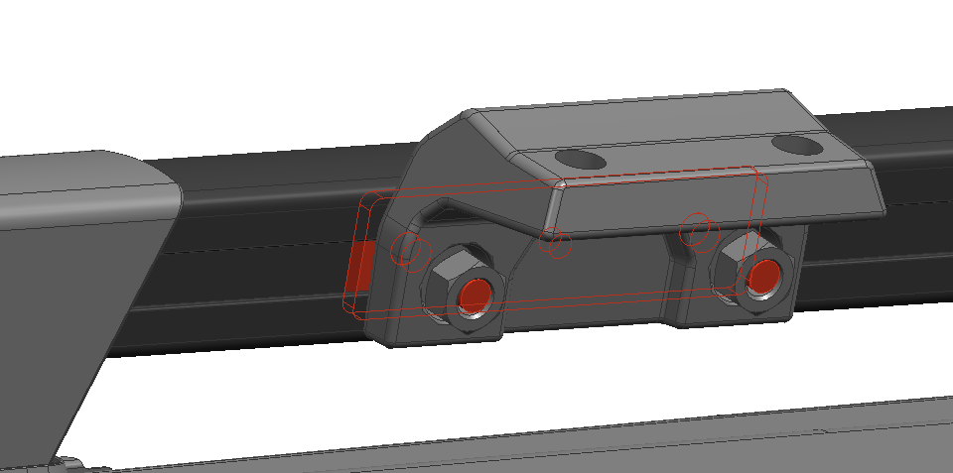
2 | 安装支架与车顶平台本体连接：  取出安装支架，与提前安装好的定制螺丝架,预安装不要紧固，使用M8法兰螺帽*2，如图安装，一边3个。  注意：此处为预固定。  Take out the installation bracket and pre-install it with the pre-installed screw bracketm but not tighten. Use M8 flange nuts*2, as shown in the figure to install, 3 on each side.  Note: This is pre-fixed.
3 | 车顶平台整体放到车顶上：  需2-3人将平台置于车顶，调整前后距离，以后1安装支架为基准点。调整其余2个安装支架与平台孔位对准。  It takes 2-3 people to place the roof rack on the car roof, adjust the front and rear distance, and use the rear 1 mounting bracket as the reference point. Adjust the remaining 2 mounting brackets to align with the platform holes.  安装支架与车顶平台本体连接：  安装支架与平台，使用M8*40圆柱内六角螺栓*2+M8垫片*2+双孔垫片*1+双孔带螺母垫片*1，如图  安装支架与车顶平台本体连接（共6个支架）全部预安装后紧固所有螺丝。  To install the bracket and roof rack, use M8*40 cylindrical hexagon socket bolts*2+M8Spacer*2+double-hole Spacer*1+double-hole nut sapcer*1, as shown in the figure  The mounting brackets are connected to the roof rack body (a total of 6 brackets) and all are pre-installed before tightening all screws. | 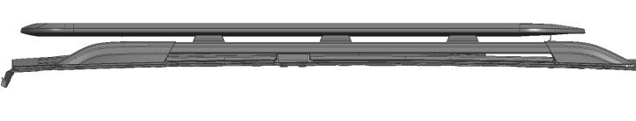  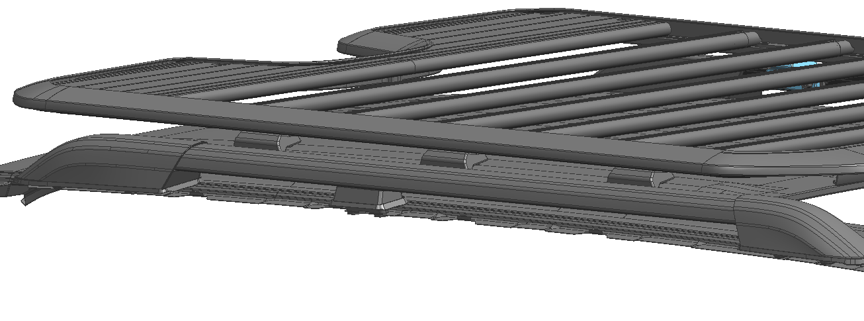  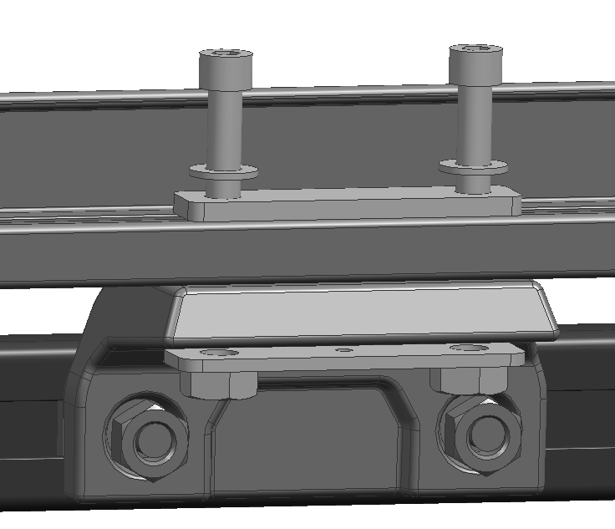  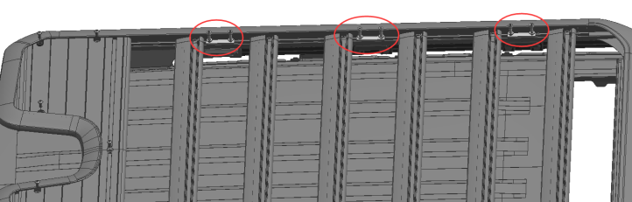
 | 安装完成总装图  Installation completed diagram | 